LAB 1 – Đỗ Hoàng Dương
Exercise 1:
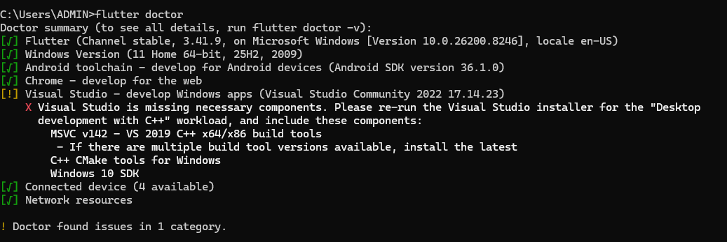
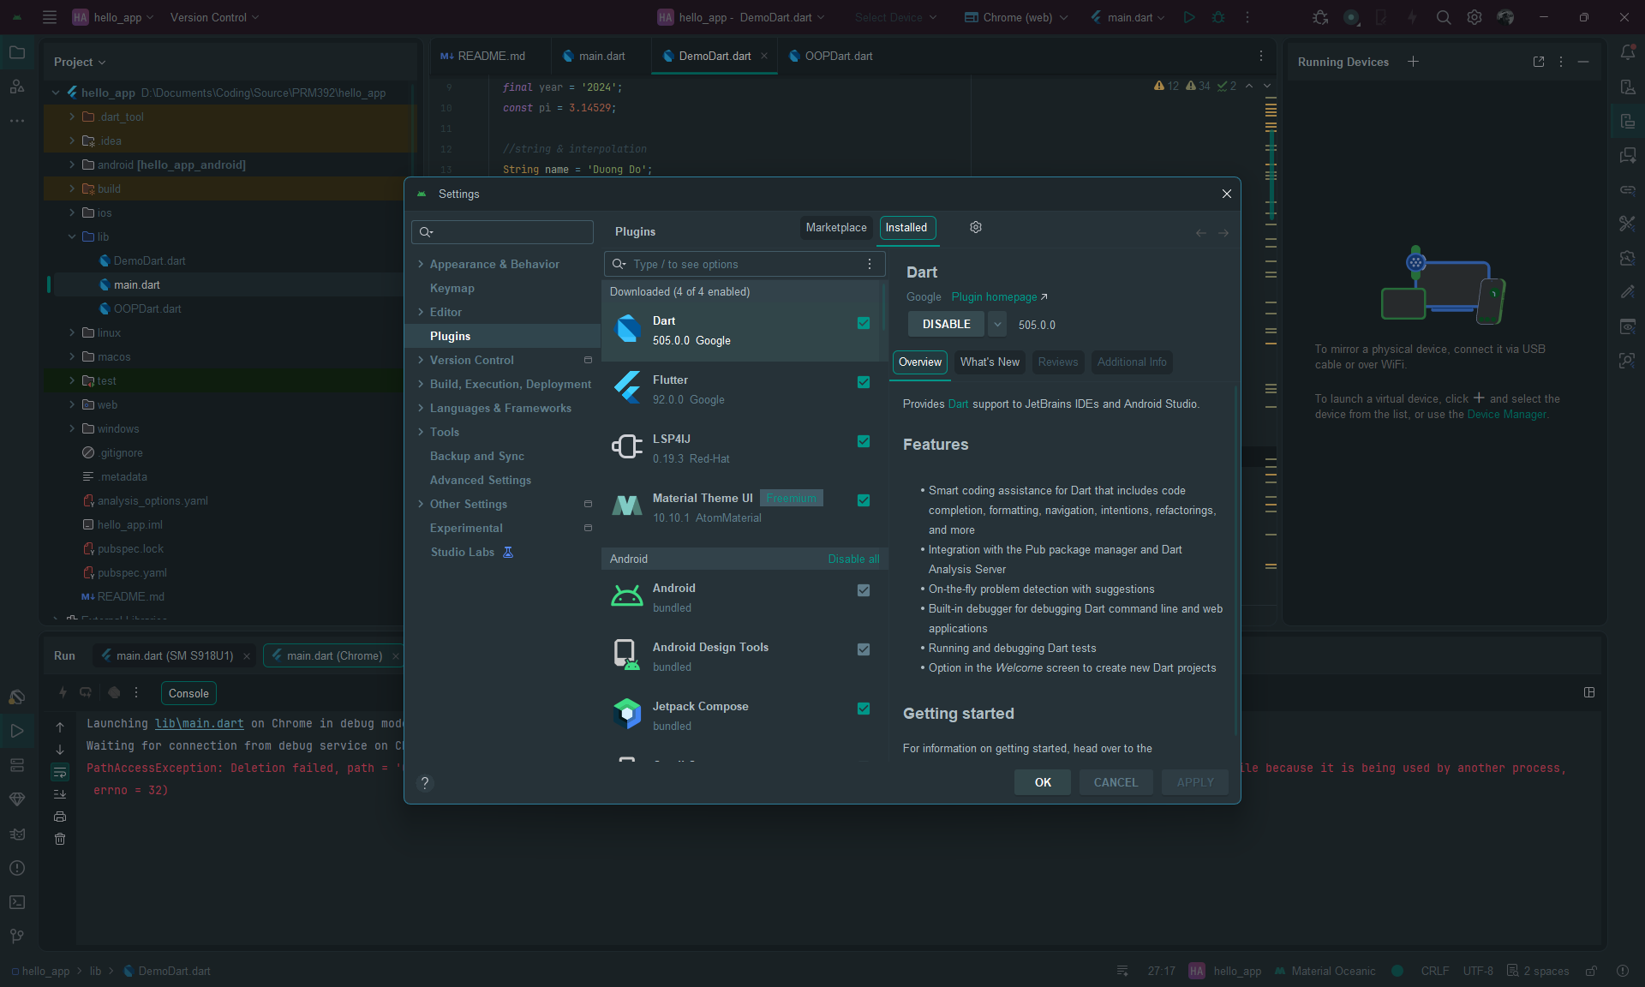

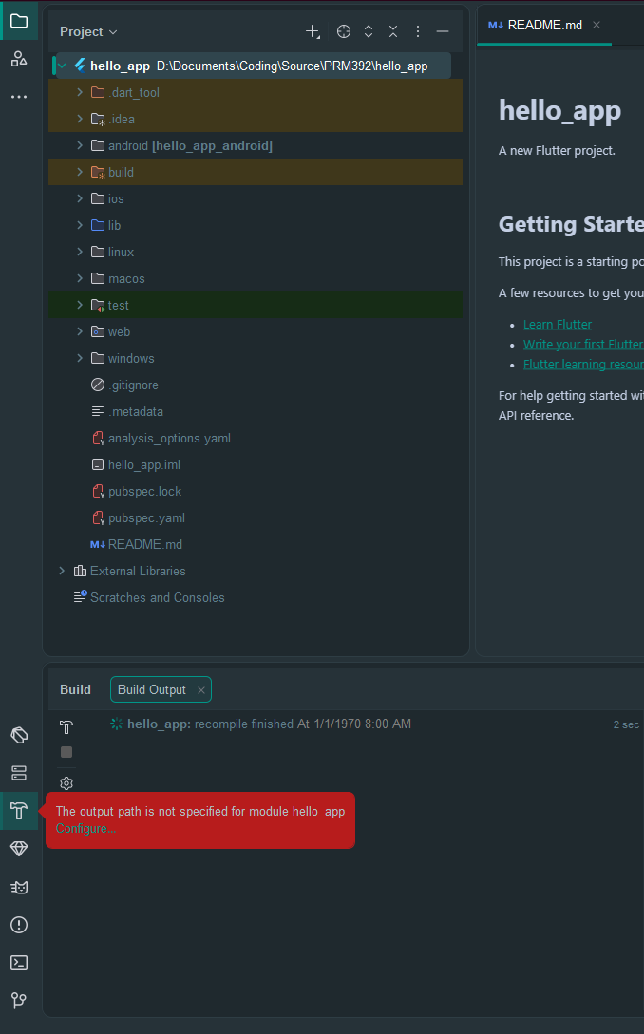
Excersise 2:
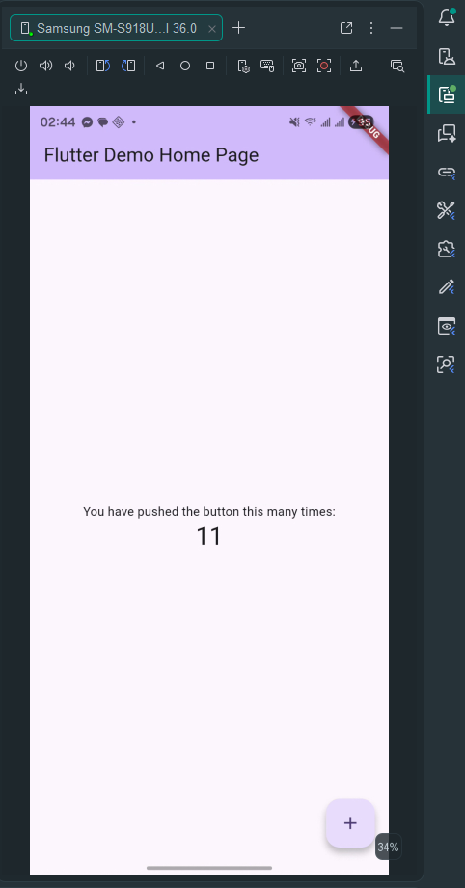

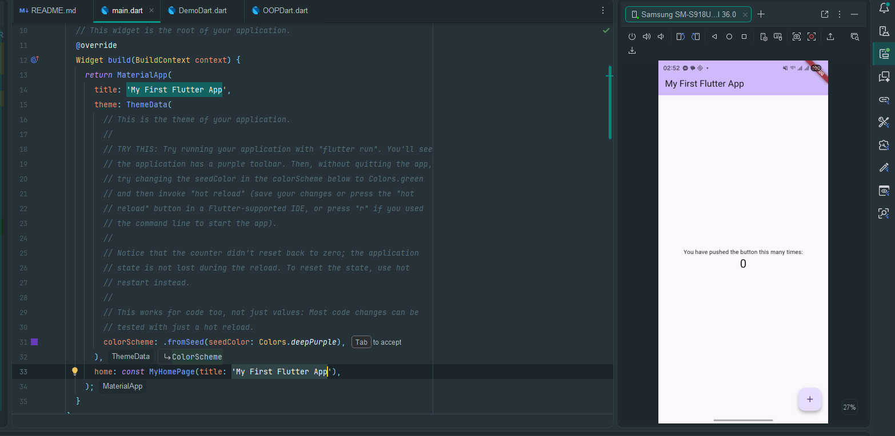
Exercise 3:
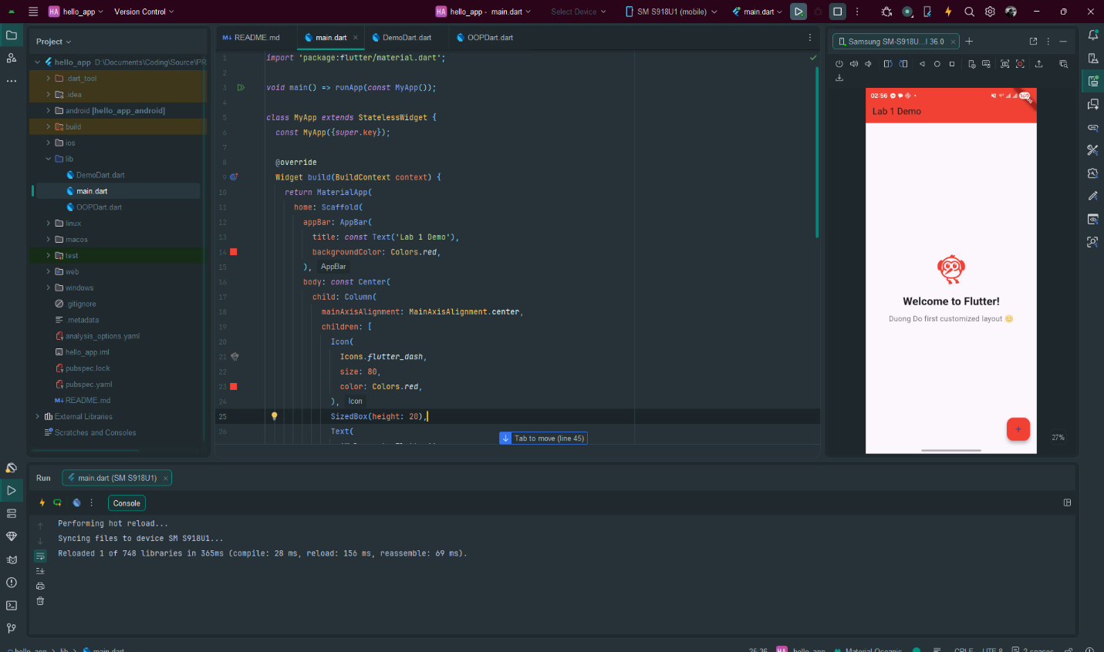

Exercise 4:
- What is the purpose of the flutter doctor command?
The flutter doctor command is used to check whether the Flutter development environment is installed and configured correctly.
It checks things like:
- Flutter SDK
- Android Studio / VS Code
- Android SDK
- Emulator or connected device
- Required dependencies
In simple words, flutter doctor helps us find and fix problems before running a Flutter app.

- What file acts as the entry point of a Flutter application?
The entry point of a Flutter application is usually the:
lib/main.dart
Inside this file, the app starts from the main() function:
void main() {
runApp(const MyApp());
}

- Explain the difference between Hot Reload and Hot Restart.
Hot Reload updates the UI quickly without restarting the whole app. It keeps the current app state.
For example, if you change a text color or font size, Hot Reload shows the change immediately.
Hot Restart restarts the whole Flutter app from the beginning. It loses the current app state and runs main() again.
For example, if you change initialization code or app-level logic, Hot Restart is often needed.

- How does runApp() build the widget tree?
The runApp() function takes the root widget of the application and attaches it to the screen.
Example:
void main() {
runApp(const MyApp());
}
Here, MyApp becomes the root of the widget tree. From MyApp, Flutter builds child widgets such as MaterialApp, Scaffold, AppBar, Center, Column, Text, and Icon.
In simple words, runApp() tells Flutter:
“Start the app using this widget as the first widget.”

- Describe how Flutter’s architecture enables cross-platform development.
Flutter enables cross-platform development by using one codebase to build apps for multiple platforms such as Android, iOS, Web, Windows, macOS, and Linux.
Flutter does not rely heavily on native UI components. Instead, it uses its own rendering engine to draw the interface on the screen. Because of this, the app can look and behave consistently across different platforms.
In simple words, developers write the code once in Dart, and Flutter helps run it on many platforms.

